

Mostafa Abdelrahman

iti

**Analytical SQL Project**

**Dataset Background**: Customers has purchasing transaction that we shall be monitoring to get intuition behind each customer behavior to target the customers in the most efficient and proactive way, to increase sales/revenue , improve customer retention and decrease churn.

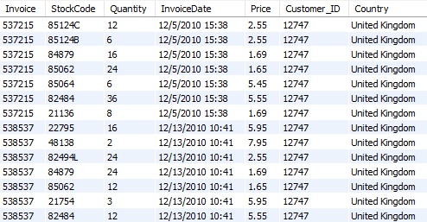

you will be required to answer using SQL Analytical functions you have learnt in the course.

**PROBLEM-1)**

• write at least **5 analytical SQL** queries that tells a story about the data

• write small **description** about the business meaning behind each query

Query1)

SELECT

DISTINCT Customer_ID,

ROUND(Price * Quantity) AS transaction_amount,

ROUND(AVG(Price * Quantity) OVER (PARTITION BY Customer_ID)) AS total_sales

FROM

tableRetail

ORDER BY transaction_amount DESC;

**Business Description**: This query provides insights into the individual transaction amounts and the overall sales performance of each customer. It calculates the transaction amount for each purchase made by customers and their average total sales, aiding in understanding customer spending behavior and identifying high-value customers.

Query2)

SELECT distinct MONTH(STR_TO_DATE(SUBSTRING_INDEX(invoicedate, ' ', 1), '%m/%d/%Y')) AS extracted_month,

round(avg(price*Quantity) over(partition by MONTH(STR_TO_DATE(SUBSTRING_INDEX(invoicedate, ' ', 1), '%m/%d/%Y')))) avg_sale,

round(sum(price*Quantity) over(partition by MONTH(STR_TO_DATE(SUBSTRING_INDEX(invoicedate, ' ', 1), '%m/%d/%Y')))) total_sale

FROM tableretail

**Business Description**: This query provides a monthly overview of sales performance, calculating the average and total sales for each month. It aids in identifying seasonal trends in customer purchasing behavior, enabling better inventory management and targeted marketing campaigns aligned with peak sales periods.

Query3)

SELECT

DISTINCT StockCode,

ROUND(SUM(Quantity) OVER (PARTITION BY StockCode)) AS total_sale

FROM

tableRetail

ORDER BY

total_sale DESC;

**Business Description:** This query delves into the quantity sold for each product stock code, offering crucial insights into the most sought-after products within the inventory. By discerning the top demanded products.

Query4)

SELECT

DISTINCT StockCode,

total_sale

FROM

(SELECT

StockCode,

SUM(Quantity) OVER (PARTITION BY StockCode) AS total_sale

FROM

tableRetail) AS subquery

WHERE

total_sale < 10

ORDER BY

total_sale ASC;

**Business Insight**: This query identifies products that have been sold fewer than 10 items. Analyzing products with low sales volume is crucial for inventory management and decision-making. It helps businesses identify slow-moving or unpopular items that may require attention, such as reevaluation of pricing, marketing strategies, or inventory levels. By addressing underperforming products, businesses can optimize resources, improve profitability, and ensure a more balanced product portfolio that aligns with customer demand.

Top of Form

Query5)

SELECT distinct (STR_TO_DATE(invoicedate, '%m/%d/%Y')) AS extracted_day,

round(price*Quantity ,2) sales,

round(avg(price*Quantity) over()) avg_daily_sales

FROM tableretail;

**Business Insights:** Identify peak and slow sales days to understand customer behavior patterns.Track short-term sales trends to inform resource allocation and promotions.

Set realistic daily sales goals based on data-driven insights.Optimize sales strategies by understanding daily sales performance.Improve overall sales performance through informed decision-making.



**PROBLEM-2)**

On the previous data set:

implement a Monetary model for customers behavior for product purchasing and segment each customer based on the below groups Champions - Loyal Customers - Potential Loyalists – Recent Customers – Promising - Customers Needing Attention - At Risk - Cant Lose Them – Hibernating – Lost The customers will be grouped based on 3 main values

• Recency => how recent the last transaction is (Hint: choose a reference date, which is the most recent purchase in the dataset )

• Frequency => how many times the customer has bought from our store

• Monetary => how much each customer has paid for our products As there are many groups for each of the R, F, and M features, there are also many potential permutations, this number is too much to manage in terms of marketing strategies. For this, we would decrease the permutations by getting the average scores of the frequency and monetary (as both of them are indicative to purchase volume anyway)

Label each customer based on the below values

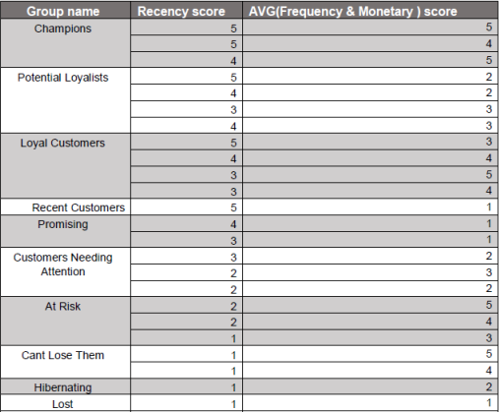

Here’s the query:

with t1 as (

(select distinct count(*) over(partition by Customer_ID) frequency, customer_id,

sum(price*Quantity) over(partition by Customer_ID) total_customer_sale,

max(STR_TO_DATE(SUBSTRING_INDEX(InvoiceDate, ' ', 1), '%m/%d/%Y' )) over(partition by customer_id) recent_purchase

from tableretail)

),

t2 as (

select distinct customer_id, STR_TO_DATE('2011/29/12', '%Y/%d/%m') - recent_purchase recency, frequency,

round(percent_rank() over(order by total_customer_sale),2) monetary,

ntile(5) over(order by STR_TO_DATE('2011/29/12', '%Y/%d/%m') - recent_purchase desc) r_score,

ntile(5) over(order by frequency) f_score,

round(((round(percent_rank() over(order by total_customer_sale),2)+.01)*5 + ntile(5) over(order by frequency))/2) fm_score

from t1 )

select Customer_ID, recency, frequency, monetary, r_score, fm_score,

case when (r_score = 5 and fm_score = 5) or (r_score = 4 and fm_score = 5) or (r_score = 5 and fm_score = 4) then 'Champions'

when (r_score = 5 and fm_score = 2) or (r_score = 4 and fm_score = 2) or (r_score = 4 and fm_score = 3) or (r_score = 3 and fm_score = 3) then 'Potenial Loyalist'

when (r_score = 5 and fm_score = 3) or (r_score = 4 and fm_score = 4) or (r_score = 3 and fm_score = 5) or (r_score = 3 and fm_score = 4) then 'Loyal Customer'

when (r_score = 5 and fm_score = 1) then 'Recent Customers'

when (r_score = 4 and fm_score = 1) or (r_score = 3 and fm_score = 1) then 'Promising'

when (r_score = 3 and fm_score = 2) or (r_score = 2 and fm_score = 3) or (r_score = 2 and fm_score = 2) then 'Customers Needing Attention'

when (r_score = 2 and fm_score = 5) or (r_score = 2 and fm_score = 4) or (r_score = 1 and fm_score = 3) then 'At Risk'

when (r_score = 1 and fm_score = 4) or (r_score = 1 and fm_score = 5) then 'Can"t Lose Them'

when (r_score = 1 and fm_score = 2) then 'Hybernating'

when (r_score = 1 and fm_score = 1) then 'Lost'

end cust_segment

from t2;



This query segments customers into different categories based on their purchase history. Here's a breakdown of the steps involved:

1. **Create CTEs (t1 and t2):**
   * **t1:** Calculates various customer metrics like total purchase amount, recent purchase date, and purchase frequency for each customer.
   * **t2**: It takes the data from t1 and calculates additional scores and segments for each customer.
2. **Calculate customer scores:**
   * **Monetary score:** This score (between 0 and 1) reflects a customer's ranking based on their total spending compared to others.
   * **Recency score:** This score (between 1 and 5) indicates how recently a customer made a purchase, with 5 being the most recent.
   * **Frequency score:** This score (between 1 and 5) represents a customer's purchase frequency compared to others, with 5 being the most frequent.
   * **FM Score:** This combines the monetary and frequency scores (between 1 and 10) to get a holistic view of customer value.
3. **Segment customers:**
   * Based on the recency and FM scores, the query assigns each customer a segment label like "Champions," "Loyal Customer," "At Risk," etc. These labels represent different customer categories based on their purchase behavior.



**PROBLEM-3)**

Given the following data set as csv file

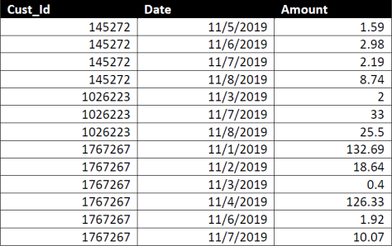

**1)**

What is the maximum number of consecutive days a customer made purchases?



Here’s the query:

WITH source_cte AS (

SELECT

cust_id,

calendar_dt,

LEAD(calendar_dt) OVER(ORDER BY cust_id, calendar_dt) AS lead_cal,

LEAD(calendar_dt) OVER(ORDER BY cust_id, calendar_dt) - calendar_dt AS streak,

CASE

WHEN COALESCE(difference1, 2) != 1 THEN 'start new streak'

WHEN difference2 != 1 THEN 'end streak'

ELSE 'inside'

END AS label

FROM (

SELECT

cust_id,

calendar_dt,

LAG(calendar_dt) OVER(ORDER BY cust_id, calendar_dt) AS lagged_date,

calendar_dt - LAG(calendar_dt) OVER(ORDER BY cust_id, calendar_dt) AS difference1,

LEAD(calendar_dt) OVER(ORDER BY cust_id, calendar_dt) - calendar_dt AS difference2

FROM transactions

)

WHERE (difference2 != 1 OR COALESCE(difference1, 2) != 1)

)

SELECT DISTINCT

cust_id,

MAX(streak) OVER(PARTITION BY cust_id) AS max_streak

FROM source_cte

WHERE label = 'start new streak' AND streak > 0

ORDER BY cust_id;



**Breakdown of the provided SQL code:**

**1.** source_cte **(Common Table Expression):**

**a. Subquery:**

* This subquery calculates several columns for the main CTE:
  + lagged_date: The previous calendar date for each customer, using the LAG window function.
  + difference1: The difference between the current and previous calendar date.
  + difference2: The difference between the current and following calendar date.

**b. Main query within** source_cte**:**

* Selects cust_id, calendar_dt, and the results from the subquery.
* Uses a WHERE clause to filter rows where either difference2 (difference with next date) or COALESCE(difference1, 2) (coalesced difference with previous date) is not equal to 1. This selects rows potentially marking the beginning or end of streaks.
* Calculates streak: The difference between the current and next calendar date, indicating the streak length.
* Assigns labels ('start new streak', 'end streak', or 'inside') based on the calculated differences and the previous difference (using COALESCE to handle potential null values).

**2. Main Query:**

* Selects distinct cust_id and the maximum streak for each customer.
* Uses MAX function with a partition by cust_id to find the maximum value of streak within each customer group.
* Filters the source_cte for rows with the label 'start new streak' and a streak greater than 0 (to exclude potential initial gaps).
* Orders the results by cust_id.

**Overall, this code identifies customer IDs, their longest streaks of consecutive days, and potentially marks the beginning of each new streak for further analysis.**

**2)**

On average, How many days/transactions does it take a customer to reach a spent threshold of 250 L.E?

From what I understood, I needed to count the number of transactions or days on which the customer made transactions until they reached a total spending of 250 L.E. in the store.

Here’s the query:

SELECT DISTINCT ROUND(AVG(trans_count) OVER(),2) avg_tans_count

from (SELECT DISTINCT cust_id, COUNT(*) OVER(PARTITION BY cust_id) + 1 AS trans_count

FROM (

SELECT cust_id, calendar_dt,

SUM(AMT_LE) OVER(PARTITION BY cust_id ORDER BY calendar_dt) AS running_total

FROM transactions

) t1

WHERE running_total < 250 AND cust_id IN (

SELECT cust_id

FROM (

SELECT cust_id, calendar_dt,

SUM(AMT_LE) OVER(PARTITION BY cust_id ORDER BY calendar_dt) AS running_total

FROM transactions

) t2

GROUP BY cust_id

HAVING MAX(running_total) >= 250

));

Here’s the breakdown of the query:

1. **Calculated running total:** The query first calculates the running total of transactions for each customer by adding up their transaction amounts in chronological order.

2. **Identified high-spending customers:** Then, it identifies customers who have ever spent a total of $250 or more by finding the maximum running total for each customer.

3. **Filtered transactions:** The query keeps only the transactions from the high-spending customers identified in the previous step.

4. **Counted transactions:** For each high-spending customer, it counts the number of transactions they made.